BO Set up – Trial #1

- Ibraheem and Srilakshmi/Nirav - Imported the BIAR files in the CMC server
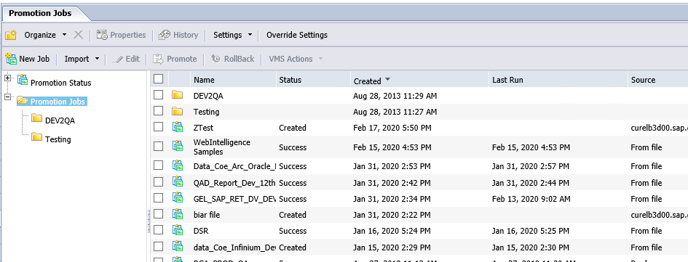
- Rohit – Installed odbc in local the 32bit 9.5.1
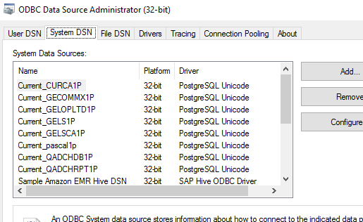
- Sriakshmi/Nirav/Hiren-Re-installed odbc in local the 11.1 as the postgress is 11.1
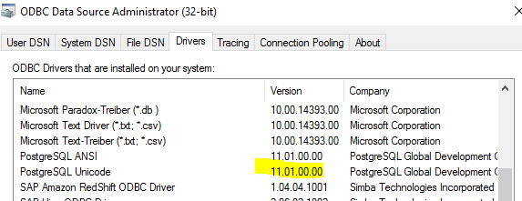
- Sriakshmi/Nirav – Created ODBC in the local connection was successful (for both 9.5.1and for 11.1 for the 32 bit ) and we could see the tabular data in the universe
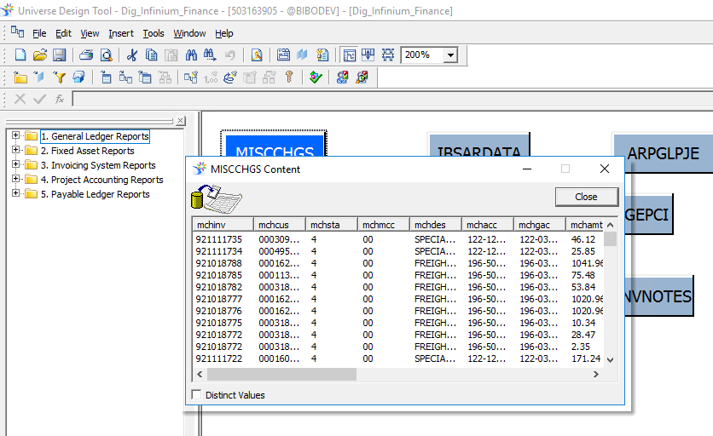
- Jane -Intalled 11.1 in the server and Created ODBC in the server connection was successful in the unix but failed in the front end(Webi)

The error from Bo server is attached below
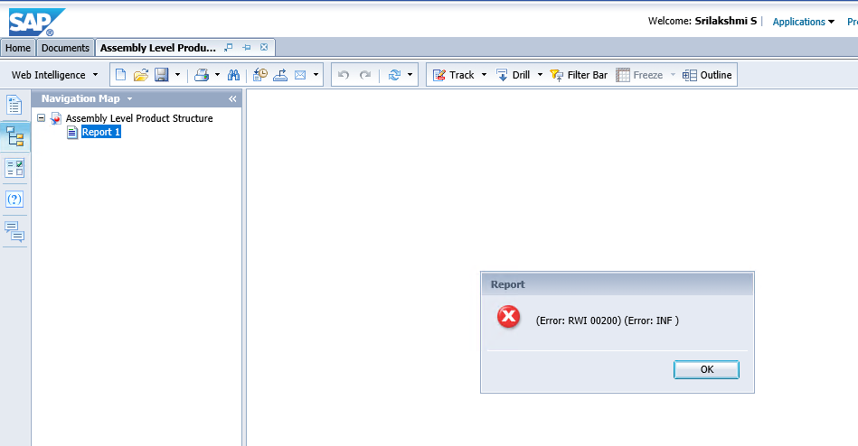
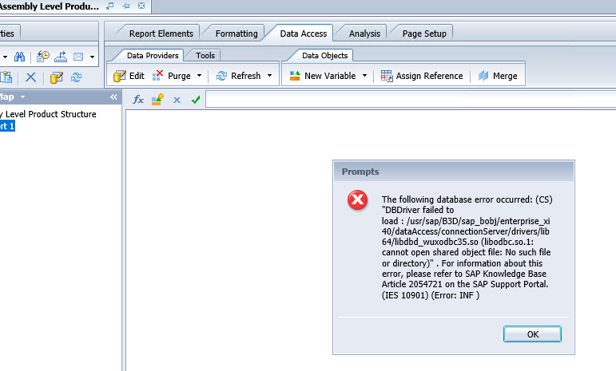

BO set up Trial #2

Testing using database

- Jane/ Srilakshmi/Nirav- Checked the security settings in the CMC
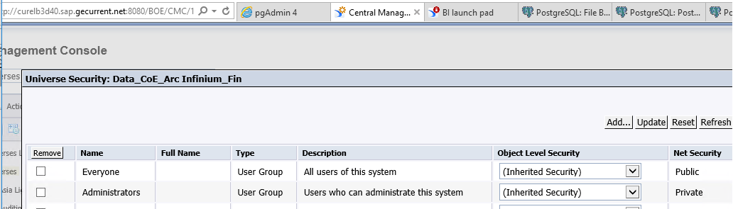
- Srilakshmi/Nirav- Created a test universe and exported it to the bo server .Successfull in the webi client but failed in webi server.
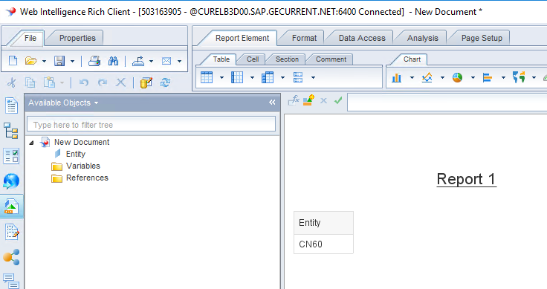
- Hiren/Srilakshmi/Nirav-Tried to create a new report in Bo server but failed to connect to any universe.
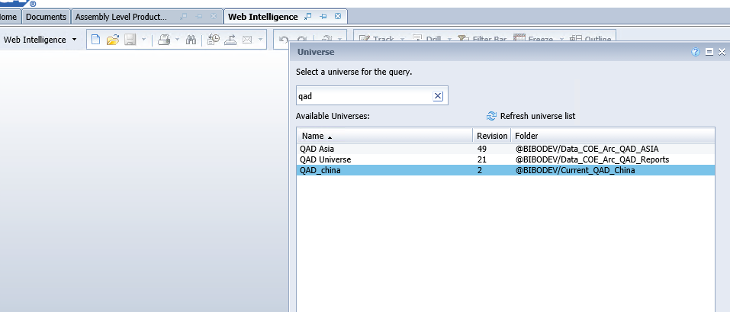
- Srilakshmi/Nirav/Hiren- Imported the universe from Biar files and made the changes to the credential and database name and exported the same for testing purpose- failed in webi server
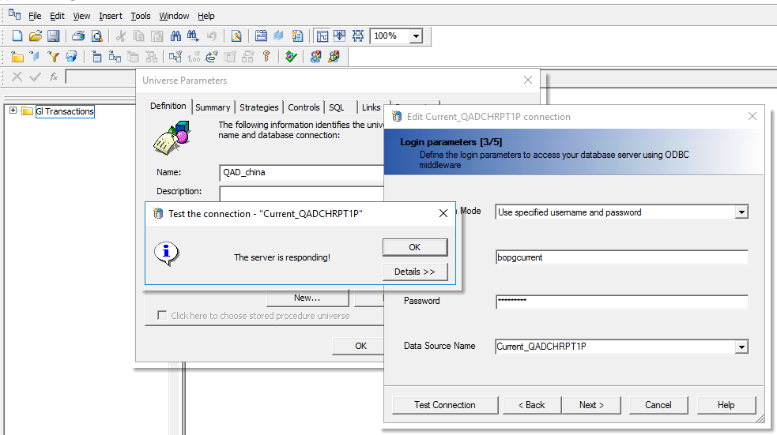
- Hiren – Provided the link for the odbc driver for the linux
- Hiren/Srilakshmi – Checked the odbc directory location and verified the same
- Hiren/Jane- worked together in the BO backend linux server end.

BO set up trial #3

Testing using excel/CSV

- Hiren/Srilakshmi/Nirav-Created a ODBC connection for the excel/CSV and provided the same excel sheet to Ibraheem to do the same in the bo server
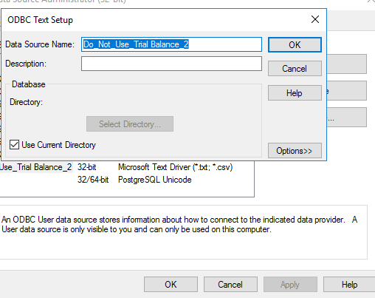
- Hiren/Srilakshmi/Nirav- Created a test universe based on an excel/CSV and exported it to the bo server .Failed in webi server.
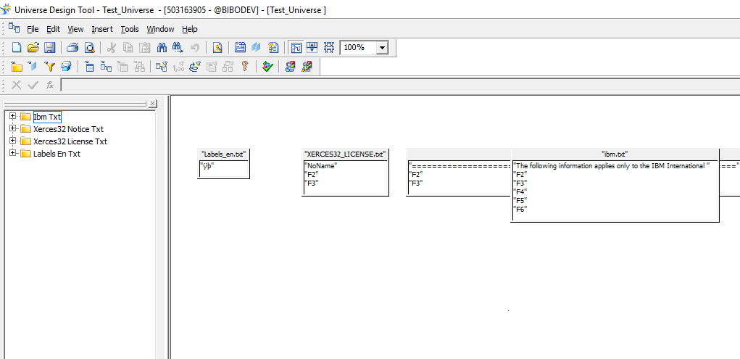

- Hiren/Srilakshmi/Nirav- Created a test webi rich client based on the excel/CSV and exported it to the bo server .Successfull in webi rich client but Failed in webi server.
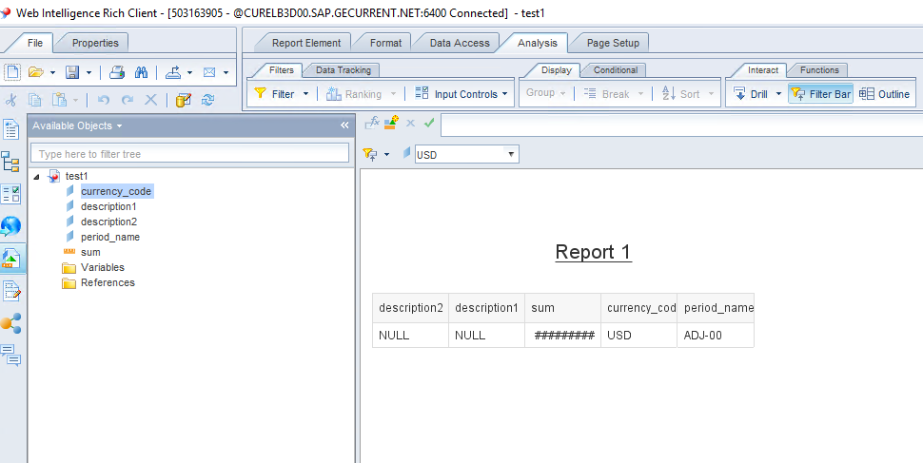
- Hiren/Srilakshmi/Nirav- Made the changes to the credential and database name for the test universe and exported the same - failed in webi server
